EXPERIMENT-1

1. Create a simple cloud software application and provide it as a service using any Cloud Service Provider to demonstrate Software as a Service.

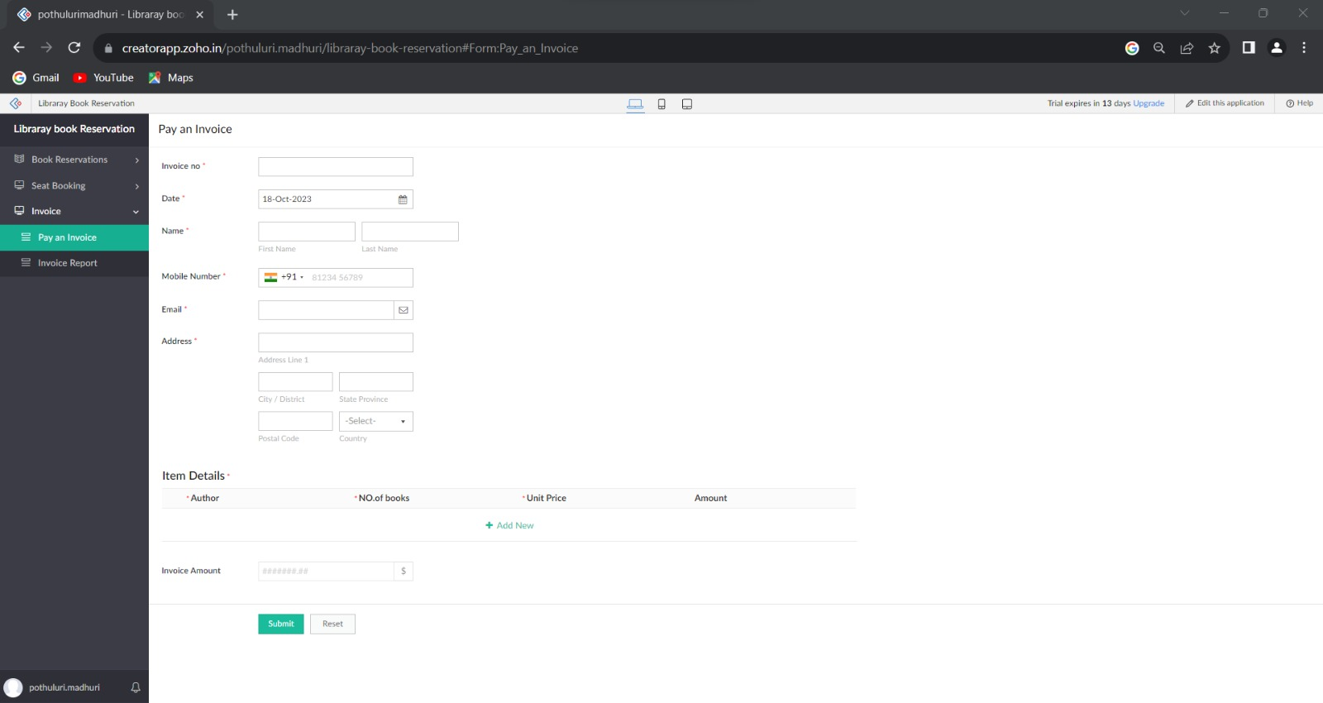





NAME:V.LOKESH

REG NO: 192210291